Door to Door Services
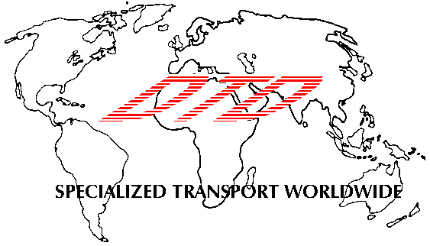
Newark International Airport ● P.O. Box 1054 ● Newark, NJ 07101
Tel: 1 908 707 0077 ● Fax: 1 908 707 0011
Email: info@dtdusa.com

11/12/2010

On November 8, 2010 all airlines, including cargo carriers, received a Transportation Security Administration (TSA) issued security directive introducing a new class of cargo identified as “elevated risk cargo” which includes:

- Cargo described as “personal effects” or “household goods” or has commodity information that is missing or inaccurate.
- Shipments paid for by cash or personal check, or shipped cash on delivery.
- Shipments from a shipper that does not have an established business relationship of more than 30 calendar days and an established shipping and billing address.
- Cargo accepted from an International Air Transport Association (IATA) registered agent, other cargo agent, freight forwarder, consolidator, or air carrier that does not have an established business relationship of more that 30 calendar days and an established shipping and billing address.
- Cargo accepted from an aircraft operator’s direct employees or authorized representatives.

In addition to enhanced physical screening measures, this directive requires all non-U.S. origin shipments given to any aircraft operator to be accompanied by a Master Air Waybill Acceptance Statement. This statement, provided to each forwarder by the aircraft operator, must include account history, method of payment, and a description of the goods, and is necessary for an aircraft operator to determine what security measures they must apply in accordance with their security directive or emergency amendment. By providing this statement, the forwarder is attesting to the accuracy of the information for the shipment.

This security directive will be in effect as of Monday, November 15th 2010, and is in place until further notice.

More details regarding the U.S. restrictions may be found at www.TSA.gov

This document is also posted as a link on our website; www.dtdusa.com, under “US Imports”

